REGISTER API
http://localhost:5000/api/auth/register
Login API
http://localhost:5000/api/auth/login
json:
{
"name": "Admin",
"email": "admin@gmail.com",
"password": "123456"
}
email: admin@gmail.com
password: 123456
tokens how to get
You get the token from:
✅ LOGIN API RESPONSE
When you login successfully using:
POST
http://localhost:5000/api/auth/login
the backend sends response like:
{
"_id": "6a0ecad73837783a4b154cac",
"name": "Admin",
"email": "admin@gmail.com",
"role": "sales_executive",
"token": "eyJhbGciOiJIUzI1NiIsInR5cCI6IkpXVCJ9..."
}

THIS PART IS THE TOKEN
eyJhbGciOiJIUzI1NiIsInR5cCI6IkpXVCJ9...
Copy it.

HOW TO GET TOKEN AGAIN
STEP 1 — OPEN POSTMAN

STEP 2 — LOGIN API
METHOD
POST
URL
http://localhost:5000/api/auth/login

STEP 3 — BODY → RAW → JSON
{
"email": "admin@gmail.com",
"password": "yourpassword"
}

STEP 4 — CLICK SEND

STEP 5 — COPY TOKEN
Response:
{
"token": "eyJhbGciOiJIUzI1NiIsInR5cCI6IkpXVCJ9..."
}
Copy token value.

STEP 6 — USE IN LEADS API
Go to Leads API request.
Inside Headers:
KEY | VALUE
Authorization | Bearer token_here
Example:
Bearer eyJhbGciOiJIUzI1NiIsInR5cCI6IkpXVCJ9...

EASIER METHOD (FROM BROWSER)
Since your frontend stores token in localStorage:
Open browser →
Press:
F12
↓
Go to:
Application
↓
Local Storage
↓
http://localhost:5173
↓
You will see:
token
Copy its value.
example
http://localhost:5000/api/leads
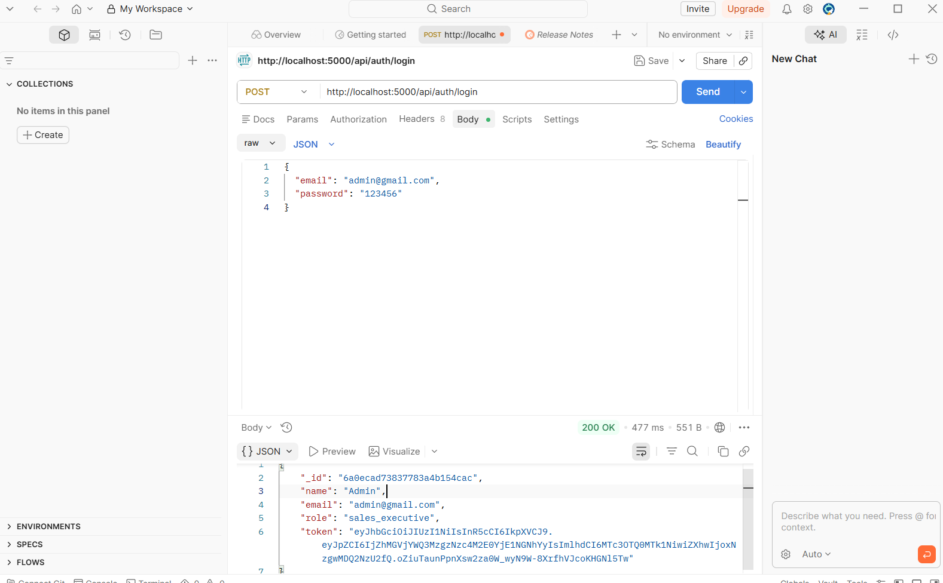

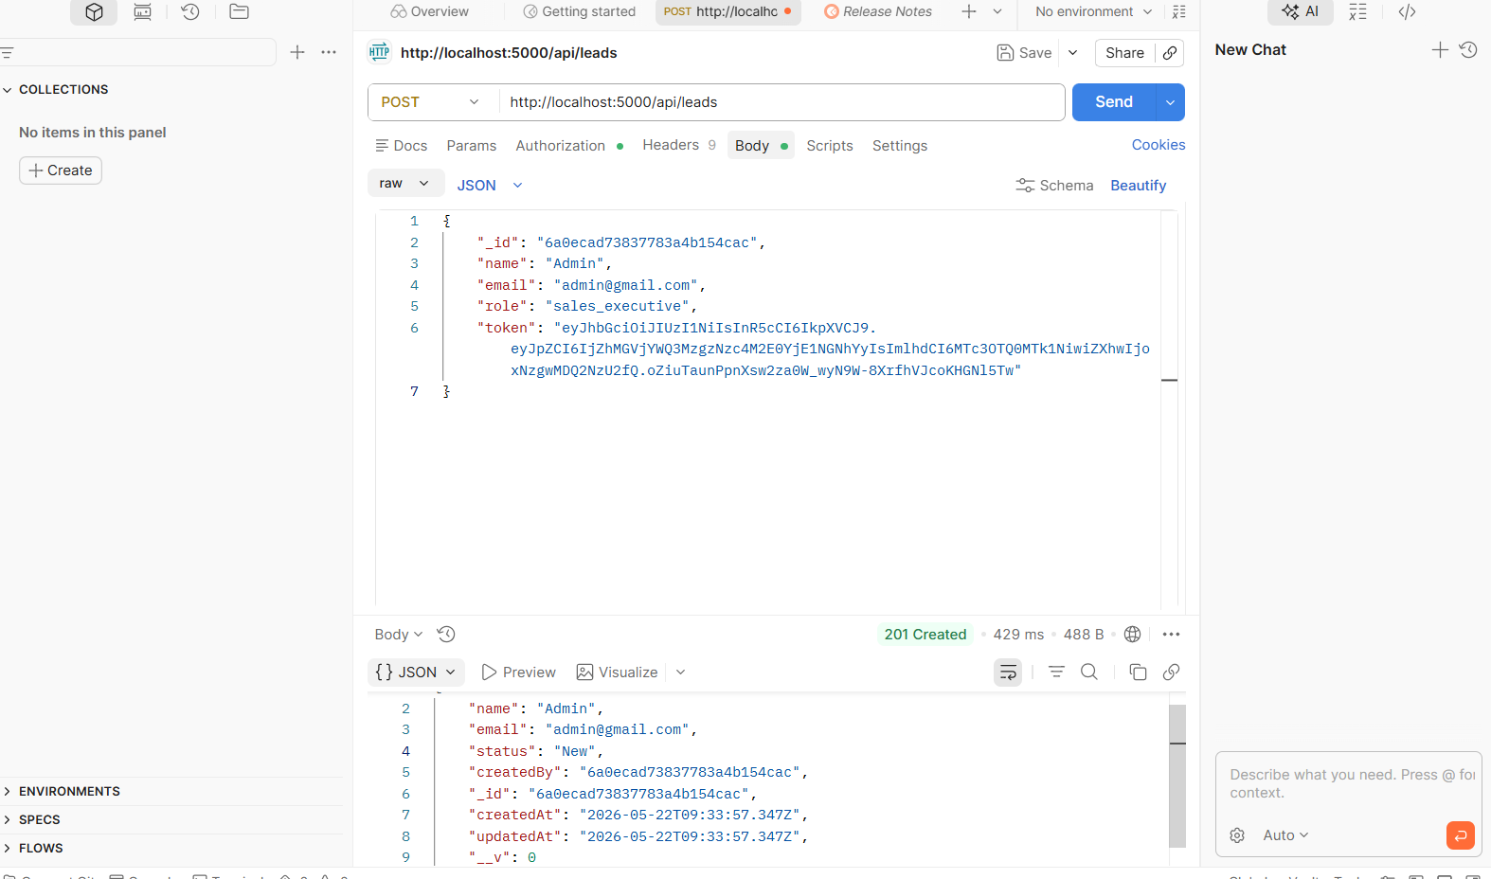

For customers module:
GET API
GET
http://localhost:5000/api/customers
post
http://localhost:5000/api/customers
body->raw->json
{
"name": "Ravi",
"company": "ABC Pvt Ltd",
"email": "ravi@gmail.com",
"phone": "9876543210"
}
output:
{
"_id": "...",
"name": "Ravi",
"company": "ABC Pvt Ltd"
}
API for tasks
TEST IN POSTMAN
GET
GET
http://localhost:5000/api/tasks

POST
POST
http://localhost:5000/api/tasks
Body → raw → JSON
{
"title": "Call Customer",
"description": "Discuss pricing",
"priority": "High",
"status": "Pending"
}

